Right Triangle Diagrams

Example Answer to Example
Complete the missing area and side length in this diagram.
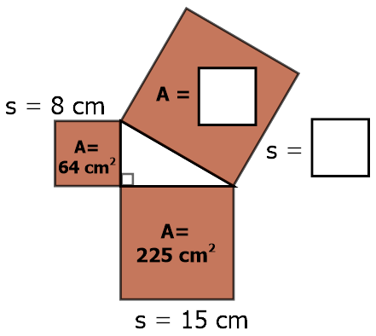
Since the triangle in the center is a right triangle, we can use The Pythagorean Theorem. Add the areas of the smaller squares to find the area of the largest, upright square.
64 + 225 = 289
The last step is to find the side length of this large square. Now that we know the area is 289 cm², we can square root that number to find the side length.
√289 = 17
The large square has sides that are 17 cm long.

Main Section
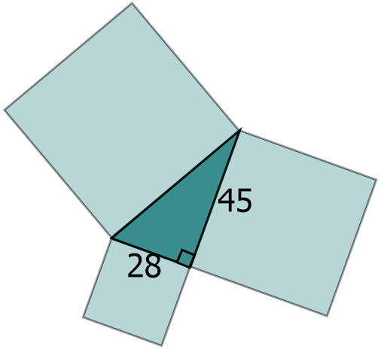

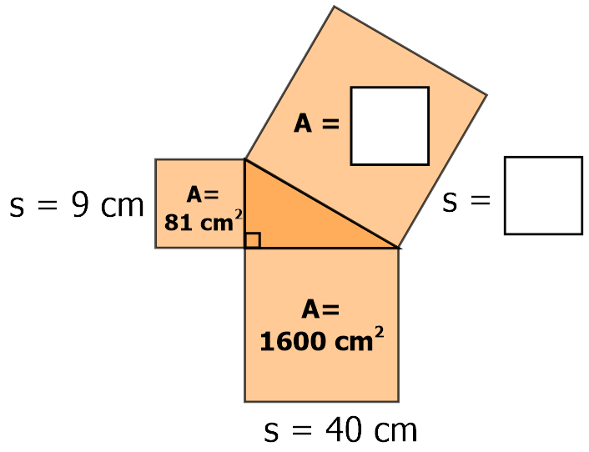
1)
3)
2) Find the areas of all three squares and also the missing length of the triangle.

4)

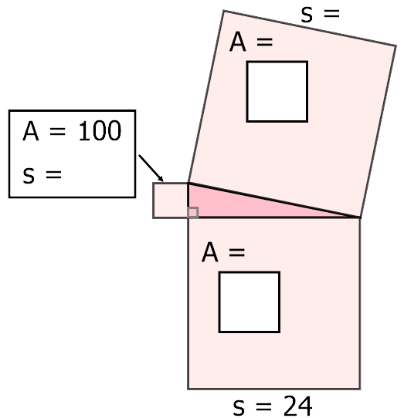
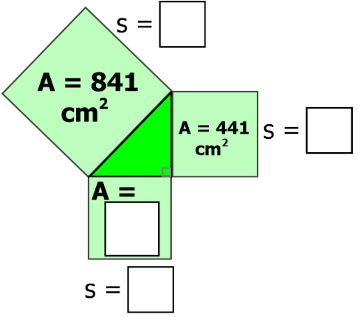

5) Draw squares on all three sides of the triangle. Label the area of the squares.

6) With this triangle, does the sum of the areas of the smaller squares equal the area of the larger square? Why or why not?

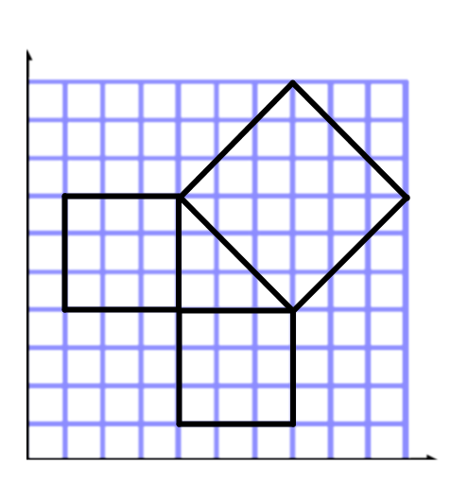
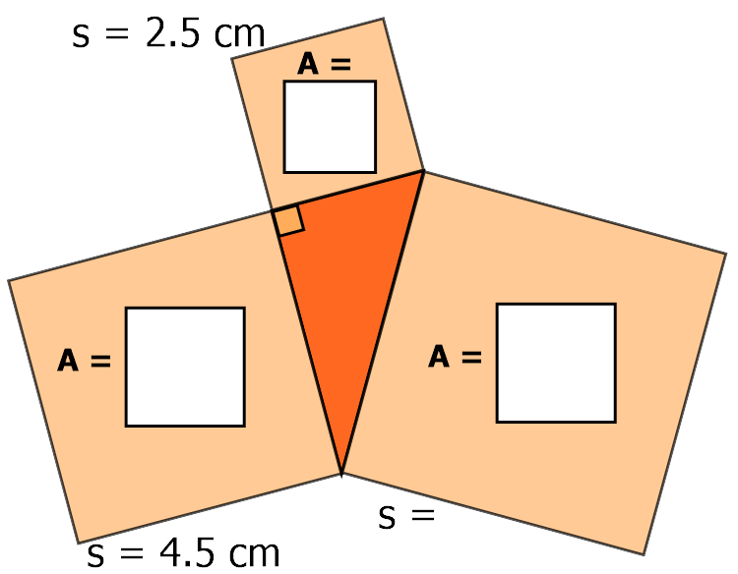
8) Label the area and the side length of each square.
7)

Answers
1) s = 41 cm A = 1681 cm² 2) side: 53 areas: 784, 2025, and 2809
3) sides: 20, 21, and 29 cm area: 400 cm²
4) sides: 10 and 26 areas: 576 and 676
5) areas: 81, 100, and 144
6) No. The Pythagorean Theorem only works with right triangles.
7) side: √26.5 ≈ 5.15 areas: 6.25, 20.25, 26.5
8) sides: 3, 3, and √18 ≈ 4.24 areas: 9, 9, and 18

