Name:
Wait a Minute! Is this Algebra?
Two-Step Solving (Include Inequalities)

Compare an Equation to an Inequality
1) Find the value of b in this simple equation: 2b + 1 = 7
Refer to the inequality 2b + 1 ≥ 7
2) List a number that is a solution to the above inequality. (A number that you could put in place of the “b” to make the math sentence true.)
3) List a number that is not a solution. (A number that would make the math sentence false is you put it in place of the “b”.)
4) What is the lowest number that is a solution? How do you know?
5) How can we quickly write all of the solutions of the inequality?
Gym Socks again?
Let’s think back one more time to the puzzle of the gym socks. Remember that the left side must have more germs than the right side. Also, every sock holds the same number of germs.
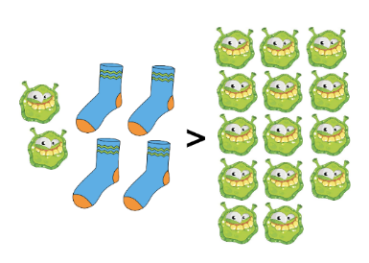
Step 1- The beginning of the puzzle

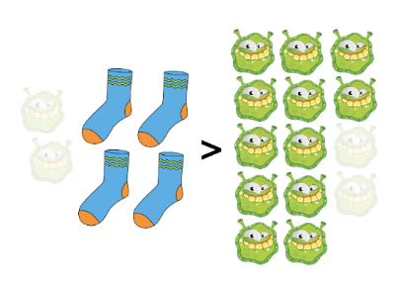
Step 2—Take away all the loose germs on the left side
To keep the same comparison, we also need to take the same number of germs from the right side.
That’s two germs from each side, to be specific.

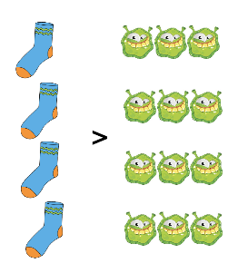
Step 3—Divide everything into groups
Since there are four treasure chests, we can see what each sock is worth if we divide the germs into four groups.
This shows us that each sock must include more than three germs.

Here we see the algebra steps for solving the same gym sock inequality.
6) How is solving an inequality similar to solving an equation? How is it different?

Below is a numberline diagram to remind you how to show a graph of an inequality solution. The circle is empty to show us that 3 cannot be a solution. The arrow points to the right, covering all the numbers that can be a solution. This emphasizes all the numbers that are solutions, and all the numbers that are not. For example, 5 is part of the solution set, but (-3) is not.
7) Name another number that is part of the solution set and another number that is not.
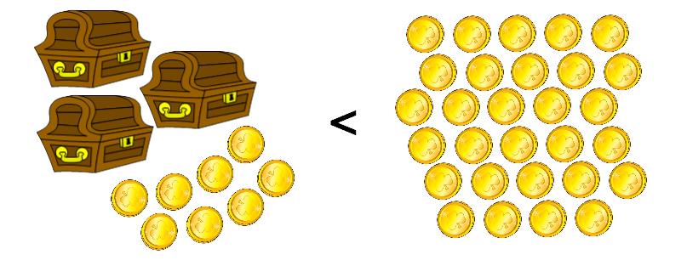
Practice
8) Each of these three treasure chests holds an equal number of coins. Write an inequality to fit the diagram.
9) Solve to find the solution set for the number of coins in one chest.
10) Express your solution set with a numberline graph.
Main Section
11) Draw a diagram to match this inequality: 6x + 7 > 31. If you’re not sure what objects to include in your diagram, we suggest envelopes and dollar bills.
12) Solve to find the solution set.
13) Express your solution set with a numberline graph.

Find the solution set for these inequalities.
14) 13 + 20d ≥ 93 15) 22f + 62 ≤ 172
16) 89 ≥ 35 + 2c 17) 805 ≤ 60d + 85
Notes
Choose which part of this study guide you think would make the best notes. Add that to your notebook.

Challenge
8x + 10 > 82 7x – 15 < 62
Suppose these two inequalities are part of a system.
The number 16 is a solution to the first inequality because 8*16 + 10 is greater than 82. But it is not a solution to the second inequality, because 7*16 – 15 is NOT less than 62.
20) Find a number that is a solution for both inequalities.
21) Find the set of all numbers that are solutions for both inequalities.
22) The system below has no solution. There are no numbers that can work for both of these inequalities at the same time. Explain why.
6x – 12 < 18 11x + 4 > 92

Answers
1) b = 3 2) Example: 4 3) Example: 2
4) The lowest solution is “3”. Example explanation: When b = 3, then the left side is equal to 7. Anything less will make the left side of the inequality less than 7.
5) b ≥ 3
6) When you’re solving an inequality, you can use the exact same steps as solving an equation. You just need to make sure to use the inequality sign pointed in the correct direction.
7) Example: 10 is part of the solution set. 1 is not part of the solution set.
8) 3x + 8 < 29 9) x < 7
10)

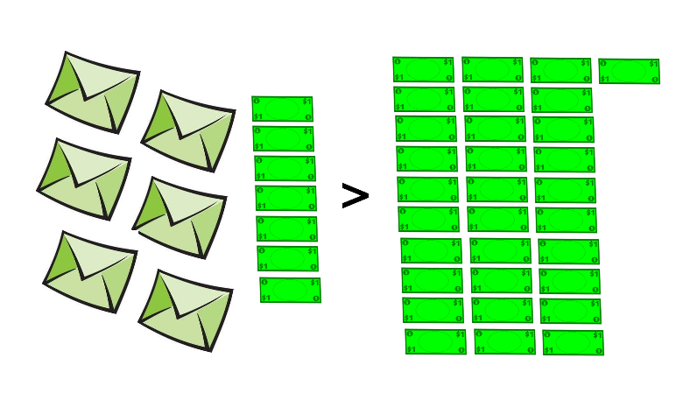
11) Example:

12) x > 4

13)

14) d ≥ 4 15) f ≤ 5
16) c ≤ 27 17) d ≥ 12

