Grid Percent

Example
Question Shade $\frac{ 3 }{25}$ of the grid. What percent of the grid is shaded?
First, we need to divide the grid into twenty-five equal groups.
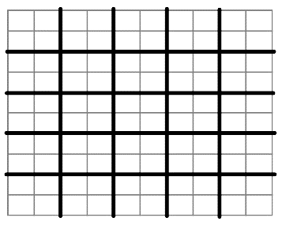
Some students might do it like this Some students might do it like this
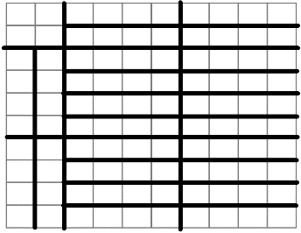

However you divide your groups, shade three of them.
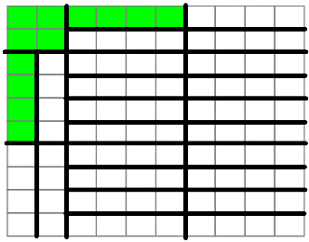
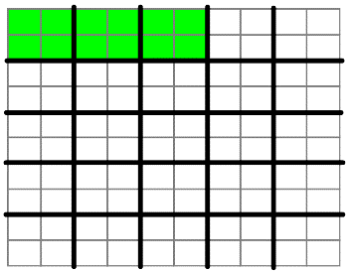

Notice that there are 100 squares in the grid. So we’ve shaded $\frac{ 12 }{100}$ of the grid.
Answer 12%
Practice
For each of these questions, shade the given fraction in a grid. You might want to use a disposable page with 100-square grids.
1) $\frac{ 9 }{10}$ 2) $\frac{ 1 }{2}$ 3) $\frac{ 3 }{4}$
4) $\frac{ 2 }{5}$ 5) $\frac{ 17 }{100}$ 6) $\frac{ 1 }{1}$
7) $\frac{ 3 }{20}$ 8) $\frac{ 7 }{50}$ 9) $\frac{ 14 }{25}$
Notes
Choose two questions to copy into your notes, along with Don’t forget the grid diagram and the final percent answer.
Challenge
10) $\frac{ 27 }{20}$ 11) $\frac{ 8 }{40}$
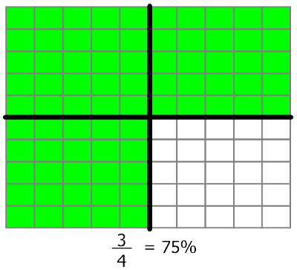
Answers
