Make a Simple Tessellation
Part A—Make your Stencil
1. Cut a piece of paper into a small square, no larger than four inches on each side. Write “PART,” with one letter in each corner.

2. Write “PART” with one letter in each corner.

3. Draw a line or curve that crosses from the top to the bottom. Don’t just draw a straight line, though. At least draw a slanted line, or make it bend in a different direction before it reaches the other side. You can even bend several times so that your line has “bumps” or “waves” or “teeth.” Your shape should look slightly different from this example.
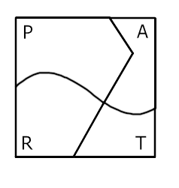

4. Draw another line or curve that crosses from the left side to the right side. Follow the same guidelines as step #2.

5. Cut out four shapes from the lines and curves that you drew.
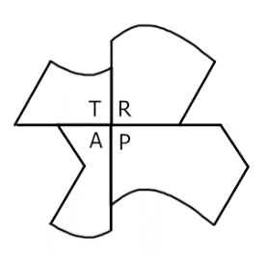

6. Tape the pieces together with the corners in the center. Your letters should spell, “TRAP.”

Part B—Use your Stencil to Tessellate another Paper
1. On a regular-sized sheet of paper, trace around your stencil.

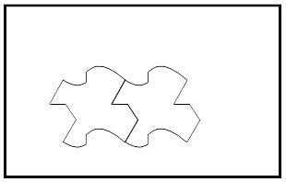

2. Move your stencil to a new spot, and trace it again.

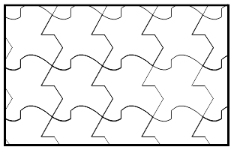
3. Repeat until you have filled the whole paper.

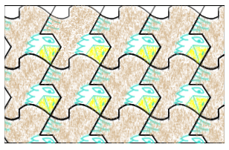
4. Decide what your shape looks like. Add details and color.

