Sticks in Dominos
Diagrams for 1x2 digit multiplication

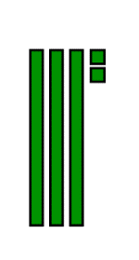
We can model “32” by drawing place value blocks like this example. The bars represent tens, and the small squares represent ones.
1) Draw a model of 43.

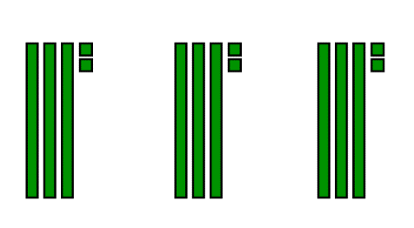
We could model 3 * 32 like this example
2) Draw a model of 2 * 43.

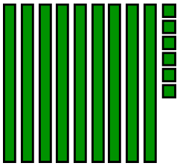
But how do we see the product? (Remember that a product is an answer to a multiplication question.) It’s helpful to sort the blocks to group tens together and ones together.
So 9 tens and 6 ones makes 96.
3 * 32 = 96
3) Re-draw your model of 2 * 43 with the tens grouped together and the ones grouped together.
4) What is the result?
We can save time if we group the tens and ones in the first step. A frame is helpful. In Mr. Z School, we call this frame a “domino”. The example domino on the left shows 3 * 32.

5) Copy the domino on the right and fill it out to show 2 * 43.
6) Draw a domino to model 7 * 11
7) Draw a domino to model 3 * 33

In big kid math, we have to regroup

So far, we’ve used pretty small numbers. This example shows what happens if we need to regroup some ones to make another ten.

Draw a model for 4 * 24.
Notice that we have a group of ten.

8) How many tens in total? 9) How many ones? 10) What is the final product?

Practice
For each problem, draw a domino to model the multiplication.
11) 5 * 13 12) 2 * 57 13) 6 * 14
14) 8 * 21 15) 9 * 22 16) 16 * 6
17) 3 * 132 (Hint: Most people draw a large square to represent 100)
18) 4 * 241
19) 2 * 1,343 (Draw 1,000 any way you want. Some people draw a cube.)
20) 6 * 8 ½
21) Check your answers to all questions so far.

Notes
Choose two questions from the “Practice” section to copy into your notes.

Challenge Section
For questions #21 through #23, draw a domino model for the multiplication question.
21) 6 * 2,657 22) 5 * 10 ½ 23) 8 * 2 ¼
For questions #24 through #28, copy the dominos and fill in all blanks.
25)
24)

27)
26)

