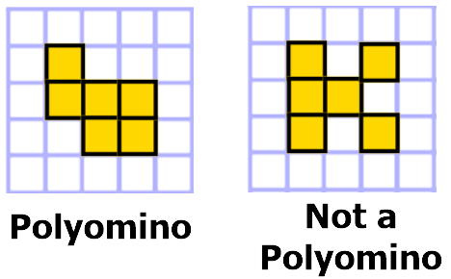
Pentominos

A polyomino is a geometric figure formed by joining equal squares on their edges (not on their corners).

Warm Up ~ The Tetrominos
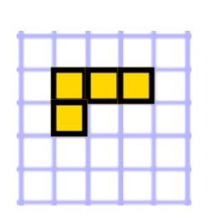
A tetromino is a polyomino made of four squares.

Tetromino #1
This figure is one of the tetrominos.
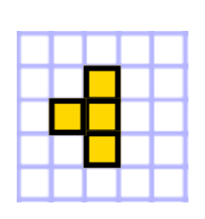

Tetromino #2
This is another tetromino.
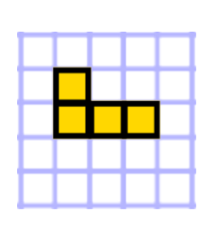

This figure does NOT count as a different tetromino. This shape is the same as tetromino #1, but it has been reflected.

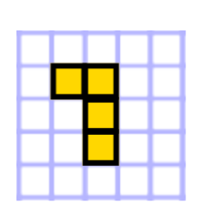
This figure also does NOT count as a different tetromino. This shape is the same as tetromino #1, but it has been rotated 90º.

1) So far, we have only shown two different unique tetrominos. There are three more ways to make a tetromino, for a total of five. Can you draw all of them? Graph paper is very useful for this activity. The answer is on the back of this page. Try not to look until you think you’ve drawn them all.

Answer ~ The five unique tetrominos
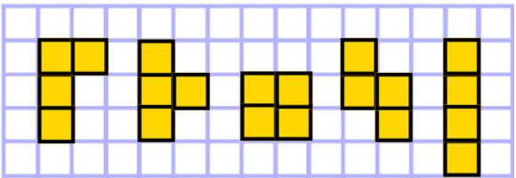
A complete answer to question #1 will include all four of these shapes.
A popular video game is named after these five shapes
Main Section
2) A pentomino is made of five squares. We won’t tell you yet how many unique pentominos there are (Okay, one hint: There are between ten and twenty). Try to draw all of them. When you think you have them all, explain why you are convinced that you’ve drawn the full collection.
The assessment for this objective will ask you to draw all of the unique pentominos. Try to find some kind of pattern or plan that will help you to remember them all. That doesn’t mean you should simply copy all of the pentominos into your notes—that wouldn’t really fit the spirit of this task. A student who finds a way to accomplish this task without referring to notes will gain significant mathematical insight.
Notes
All three diagrams from this study guide would make good notes.
Challenge
Draw all of the unique hexominos. Yep, you guessed it, a hexomino is made of six squares. (Hint: There are more than thirty).

