Nim
Nim is one of the oldest and simplest games of strategy. In this lesson, you will learn the rules of the game and play against your group members.
There are two rules:
- On you turn, you may take as many blocks as you want, but they must all be from the same row.
- The player who takes the last block wins.
Legal Moves

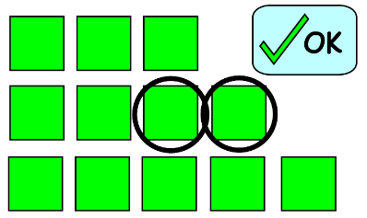
It’s okay to take these two blocks on your turn.
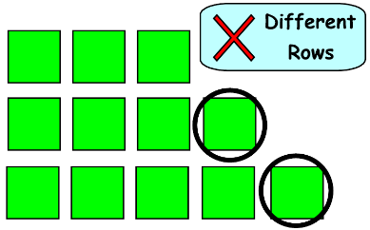
You can’t take these blocks. They’re in different rows.
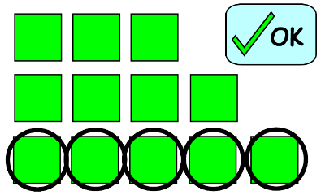
Can you take all five of these blocks? You can! They’re in the same row.

Example Game
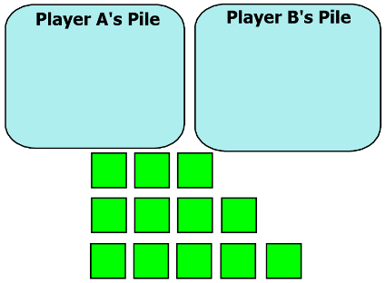  (1) A standard game starts with 12 blocks. A row of three, a row of four, and a row of five. | 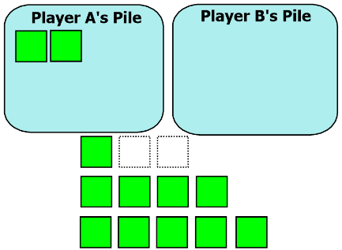  (2) Player A goes first. She takes two blocks from the top.
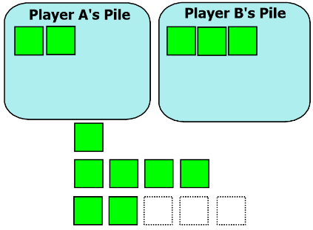  (3) Then Player B takes three blocks from the bottom. | 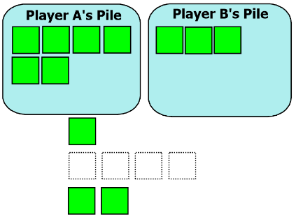  (4) Player A’s turn again. She takes the whole middle row.

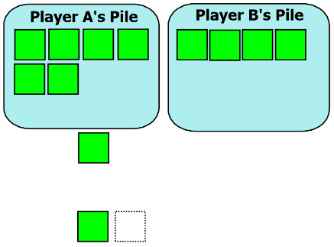  Back to Player B. He takes only one block from the bottom row. | 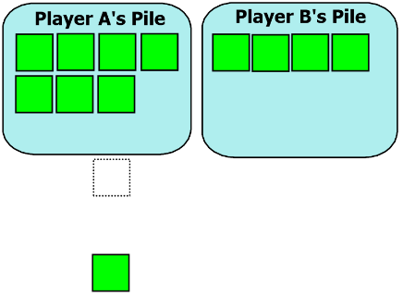  Now Player A realizes that she’s going to lose no matter which block she takes.  She takes the top block.
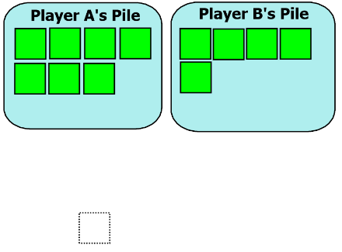
Player B takes the last block to win the game!

Instructions
Play Nim with at least two different people before you try to answer these questions. You should play at least three games against each opponent.
1) What are some winning strategies, or “tips”, that can be helpful for winning the game?
The Deadly Square!
2) If your opponent leaves you with two rows that each have two blocks, they have caught you in a trap. No matter what you do next, you’re going to lose the game (unless your opponent isn’t paying any attention). Explain why.
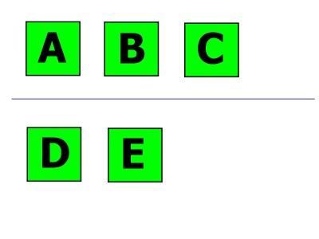 A Nim Puzzle
3) If your opponent left you with this formation, there is one way you can guarantee yourself to win. Which block could you take? Explain why. (There is more than one correct answer.)
Notes
Add your explanation of “The Deadly Square” to your notes. Why is your opponent trapped if you leave them with two rows of 2 tiles?
Challenge
4) The standard setup begins with a row of 3 blocks, a row of 4 blocks, and a row of 5 blocks. After you have answered all of the questions, try the game with a different setup. For example, try it with rows of 2, 3, 4, 5 and 6. How does this change your strategy?

