Subtract Integers, Level 1

Example — Positive Subtract Positive
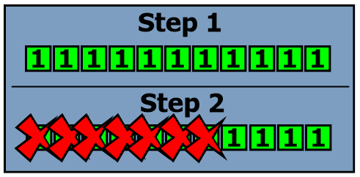
11 – 7
Step 1 Eleven positive tiles.
Step 2 Take away seven tiles
There are 4 left. So 11 – 7 equals 4.
Practice — Positive Subtract Positive
Draw a tile model to represent each problem. Write the difference (your answer) as a numeral.
1) 13 – 8 2) 19 – 7
Example — Negative Subtract Negative
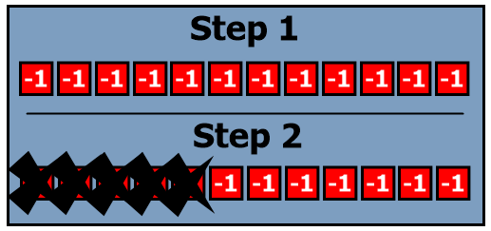
(-12) – (-5)
Step 1 Twelve negative tiles
Step 2 Take away five negative tiles.

Now there are 7 negative tiles. So (-12) – (-5) = (-7)

Practice — Negative Subtract Negative
Draw a tile model to represent each problem. Write the difference as a numeral.
3) (-11) – (-8) 4) (-21) – (-7)

Example — Small Positive Subtract Large Positive
5 – 8
Step 1 Five positive tiles
Step 2 We try to take away eight negative tiles. But there aren’t enough. We take away three more than we had. This is like having three negative tiles.
5 – 8 = (-3)
Practice — Small Positive Subtract Large Positive
Draw a tile model to represent each problem. Write the difference as a numeral.
5) 7 – 16 6) 2 – 18
Main — Mixed Subtraction
7) Refer back to the example question from the top of this page. Explain in your words why the answer is (-3).
8) Give an example of subtracting two positive numbers with a positive result. (Don’t reuse any subtraction questions that were already used in this lesson, of course. That’d be silly.)
9) Give an example of subtracting two positive numbers with a negative result.
For questions #10 through #18, give the difference (the answer). Drawing a tile model is optional.
10) (-19) – (-6) 11) 3 – 9 12) (-39) – 0
13) 15 – 38 14) (-17) – (-17) 15) (-39) – (-12)
16) 300 – 750 17) (-90) – (-25) 18) 6 – 10½
19) Check your answers to all questions so far.
Notes
Copy the three diagrams from this lesson into your notes. Label each diagram with the question that the diagram demonstrates. Also, make sure to include the answer.
Challenge
20) (-19) – (-8) – (-3) – (-1) 21) (-19) – [(-8) – (-3)] – (-1)
22) (-19) – (-8) – [(-3) – (-1)] 23) (-19) – [(-8) – (-3) – (-1)]
24) Which of these four questions has the answer with the greatest absolute value? Explain why.
Answers
1) 5 2) 12
3) (-3) 4) (-14)
5) (-9) 6) (-16)
10) (-13) 11) (-6) 12) (-39)
13) (-23) 14) 0 15) (-27)
16) (-450) 17) (-65) 18) -4 ½

