Bike and Bounce from Home
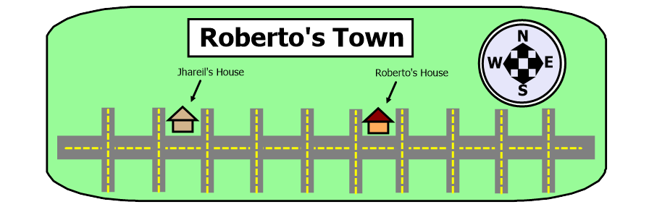
Intro to Absolute Value
A Story
Roberto spent Saturday morning riding his bike around, trying to find where his friends were hanging out. After breakfast, he left his house and rode four blocks west to see if Jhareil was home.
“Sorry Roberto,” said Jhareil’s mom. “Jhareil is over at Tate’s house.”
So Roberto rode to Tate’s house, six blocks east of Jhareil’s. On the way, he passed by his own house. His sister was playing in the front yard. When she realized that Roberto was going back the other way, she pointed at him and laughed.
“Sorry Roberto,” said Tate’s mom. “Both boys went to Hien’s house.”
Hien lives three blocks west of Tate’s house.
Roberto sighed.
On the bright side, at least all of Roberto’s friends live on the same street. When Roberto passed by his own house again, but he stuck out his tongue at his sister before she could say anything.
Thankfully, all three of his friends were at Hien’s house. Roberto sighed with relief as he parked his bike.
“Hi Roberto,” Hien said. “This is boring here. Can we go hang out at your house?”
1) At this point in the story, is Roberto east or west of his house? How far?
2) How many total blocks did he ride his bike before he got to Hien’s house?
If you’re working with a group, discuss your answers before moving on.
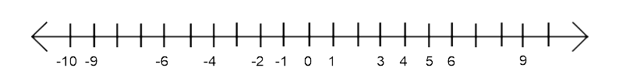
A Number Line
3) Draw a number line just like this one. We’ll say that Roberto’s house is at zero on the number line. (You can draw a little house above the zero if you want to.)
4) Since Jhareil lives six blocks west of Roberto, some maps would represent his house at (-6). Draw bounce marks on your number line like in this example. Write a label above the bounce marks that reads, “(-6) is six units away from zero”
5) Draw a filled-in circle on your number line to represent Tate’s house. How far is this number from zero? Draw bounce marks to illustrate your answer.
6) Draw one last circle for Hien’s house. How far is this number from zero?

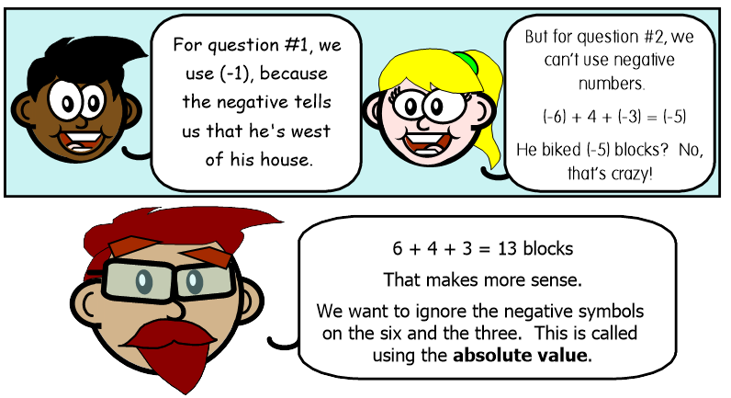

Absolute Value is all about looking at a number and asking yourself one simple question:

How far is that number from zero?

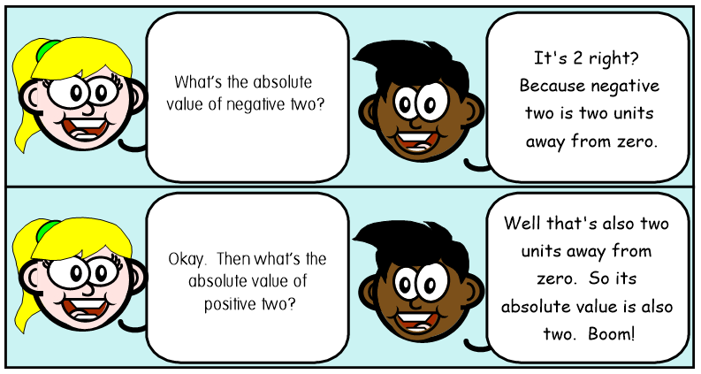
7) What is the absolute value of (-9) ? 8) What is the absolute value of 5?
If you’re confused, check your answer to the #7 and #8 before moving on.
9) The number line that you drew earlier is missing some numbers. Write the 7, 10, (-5) and (-8) in the proper spaces.
10) What is the absolute value of 10? 11) What is the absolute value of -8?

Compare absolute values
For questions #12 through #15, you are given two numbers. Tell which of the two has greater absolute value.
12) 7 or (-2) 13) 1 or (-9) 14) 85 or 75 15) (-7) or (-11)
16) What do you notice from answering these four questions? (This is a good question to discuss out loud)
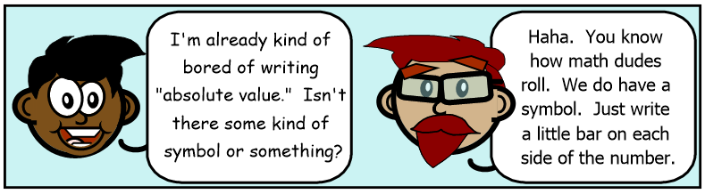
Now we’ll give you the shortcut!
|-4| = 4
This math sentence says, “The absolute value of negative four equals four.”

How do you pronounce these two math sentences?
Suggestion: Answer these two questions out loud.
17) |-13.5| = 13.5 18) |782| = 782
For questions #19 and #20, rewrite the sentence using math symbols instead of words.
19) “The absolute value of -17.25 is 17.25”
20) “The absolute value of 8 ¾ is 8 ¾”
For questions #21 through #23, copy out the math sentence and fill in the blank
21) |5| = ___ 22) |-900| = ___ 23) |0| = ___
24) Name two different numbers that have an absolute value of 9.

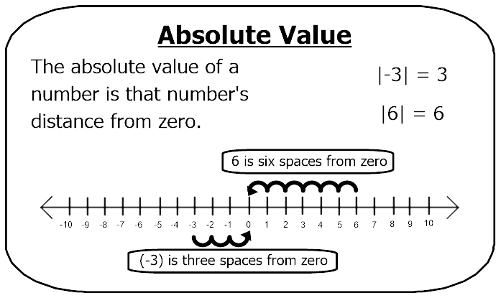
Notes

Answers
1) Roberto is one block west of his own house.
2) He rode a total of 13 blocks. (4 + 6 + 3 blocks)
5) You should mark Tate’s house at (+2), which is two units from zero.
6) You should mark Hien’s house at (-1), which is one unit from zero.
7) 9 8) 5
10) 10 11) 8
12) 7 13) (-9) 14) 85 15) (-11)
17) The absolute value of -13.5 is 13.5
18) The absolute value of 782 is 782
19) |-17.25| = 17.25
20) |8 ¾| = 8 ¾
21) |5| = 5 22) |-900| = 900 23) |0| = 0
24) 9 and (-9) both have an absolute value of 9

