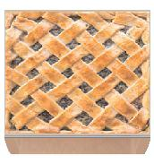
Name:
Study Guide 1573 ~ Pies Are Square
Formula for the area of a circle
Ok. Most pies are not square.
But we’ve learned that we can find the area of a circle by using the formula πr². (Pronounced “pi” “r” “squared”.)
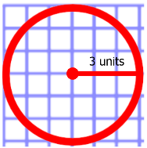  1) The radius of this circle is | 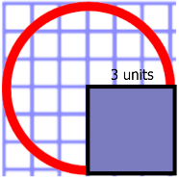  2) Here is a square where each side is | 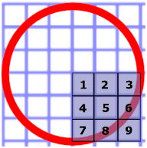  3) The area of the square is
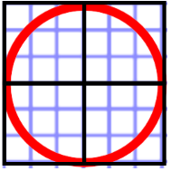  4) We can fully cover the circle if we lay out _____ of these squares | 5) But four squares is a little bit too much. There’s some extra area __________ of the circle | 6) The accurate area of the circle is really close to three of those squares. It’s actually 3.14 of those
7) The number 3.14 is known as _____ | 8) So we find the area of the square, and then _____________ it by π | 9) In this example, the circle is π x 9 u².  This is about ____ x 9 u².
10) If we calculate this, we get about ______ u². | 11) When we say that the area of the circle is 28.26 u². We mean that it would take a little bit more than ______ small squares to fill up the full circle. | 12) Of course, the squares _____ fit perfectly. You need to break some of them into pieces to fit the pieces around the edge of the circle.
13) Check your answers to above section in the box below.
1) 3 units 2) the radius of the circle 3) 9 square units
4) four 5) outside 6) those squares
7) pi or π 8) multiply 9) 3.14
10) 28.26 11) 28 12) don’t

Practice
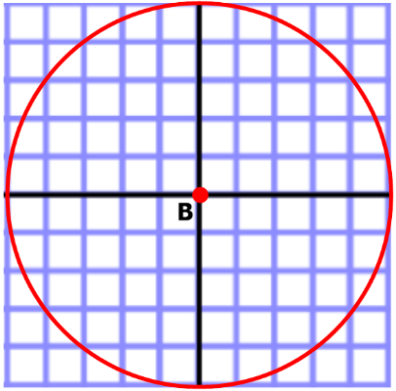
14) Refer to Circle B. Draw a square where the sides are the radius of the circle. What is the area of the square?

15) Find the circle’s area by multiplying the square by 3.14.

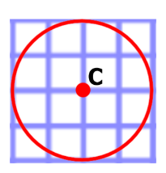
16) Refer to Circle C. Draw a square where the sides are the radius of the circle. What is the area of the square?
17) What is the area of the circle?
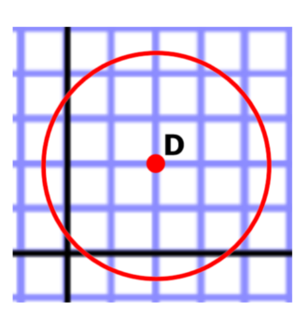
18) Refer to Circle D. Draw a square where the sides are the radius of the circle. What is the area of the square?

19) What is the area of the circle?

20) Refer to circle E. This time you don’t have a grid. What is the area of the square?

21) What is the area of the circle?

22) With Circle F, we’re no longer drawing the square for you. (But you can draw your own if you feel like that helps.) What is the area of the circle?

For questions 23 through 29, find the area of the circle
25)
24)
23)

26)
27)
28)

Answers
14) 25 u²
15) 78.5 u²
16) 4 u²
17) 12.56 u²
18) 6.25 u²
19) 19.625 u²
20) 49 u²
21) 153.86 cm²
22) 200.96 cm²
23) 530.66 cm²
24) 1,256 cm²
25) 31,400 cm²
26) 346.185 cm²
27) $\frac{1}{4} π m^{2}, or about 0.785 m^{2}$
28) 452.16 cm²

