Name:
Study Guide 1782 ~ Cylinder Volume
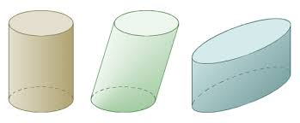

A cylinder is a solid shape with two circular bases.
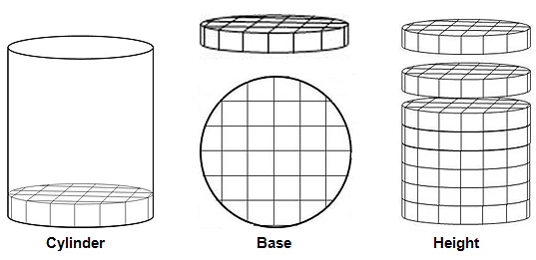

If you need to find the volume, it is helpful to view the cylinder as a stack of discs.

Find the Volume
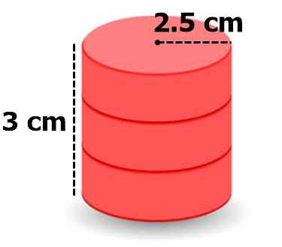
Each disc is a circle. We can find the area of one disc using the formula π r². The radius is 2.5 and the height is 3 cm.
π 2.5² = π x 2.5 x 2.5 = π x 6.25
For all calculations in this lesson, use 3.14 as your approximation for π.
3.14 x 6.25 ≈ 19.63 cm²
Each disc has volume of about 19.63 cm².
With a height of 3 cm, we can picture that the cylinder is made from three of those circles stacked on top of each other. So the total volume of the cylinder is about 19.63 x 3.
≈19.63 x 3 ≈ 58.89 cm³
Practice
Find the volume of each cylinder

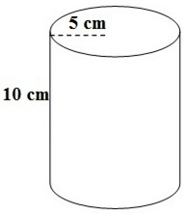
1)
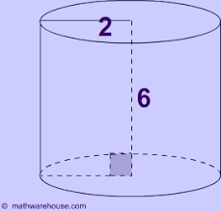
2)
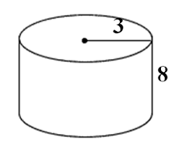
3)

Slightly Tricky Cylinders
Pay a bit closer attention as you answer these questions.

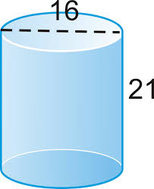
4)
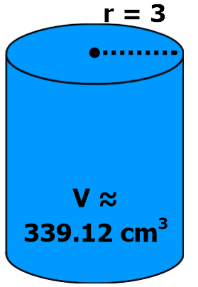
5) Find the height of this cylinder. Its volume is approximately 339.12 cm³.

Cylinders to Think About
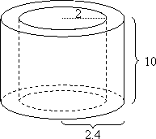
6) Find the volume of this pipe. The inner radius is 2 cm and the outer radius is 2.4 cm.

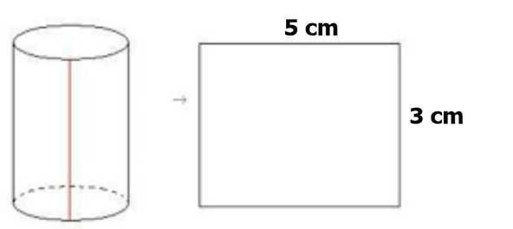
7) This cylinder was rolled from a 3 x 5 index card. Find its volume.

Answers
1) ≈ 785 cm³ 2) ≈ 75.36 cm³ 3) ≈ 226.08 cm³
4) ≈ 4220.16 cm³ 5) 12 cm
6) ≈ 55.26 cm³ 7) ≈ 6.03 cm³

