Name:
Study Guide 1702 ~ Association

Can you tell what the data dots on a graph mean? It’s a pretty useful skill. It’s sort of a psychic power, really. Think about it: you can look at a bunch of dots on a grid, and gain knowledge about bridges or money or pollution or the number of bones broken by MMA fighters. You might even learn something about goats.
Different Types of Association

Positive Association
A relationship where two variables change together. One variable increases while the other variable also increases.

No Association
A data set where two variables do not seem related. One variable increases, decreases, or stays the same, no matter the value of the other variable.
Negative Association
A relationship where two variables change opposite of each other. One variable decreases while the other variable increases.

You try

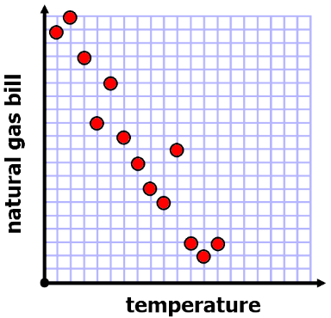
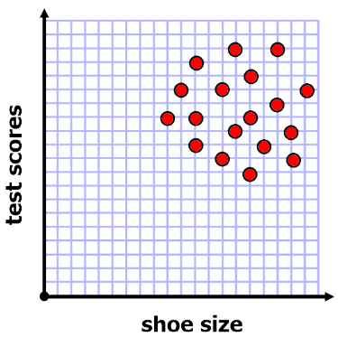
For each data set tell whether the scatterplot suggests positive, negative, or no association.

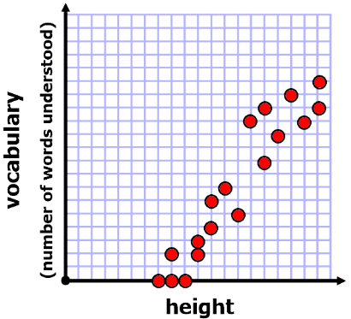
1)
2)
3)

Association Puzzle
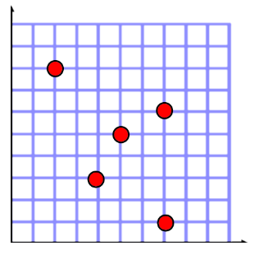
4) On the first grid, cross out two data points so that the remaining points show positive association. On the second grid, cross out two data points so that the remaining points show negative association. On the third grid, cross out one data point so that the remaining points show no association.

But what does it mean?

The length of a bridge has a negative association with its strength.
So what?
This vocabulary isn’t really worth learning unless we can use it to understand the world better.
In this case the negative association means that, as the length of a bridge increases, its capacity for weight decreases. Long bridges are weaker than short bridges.
5) What is the meaning of the association from question #2?

6) What is the meaning of the association from question #3?

Draw the Association

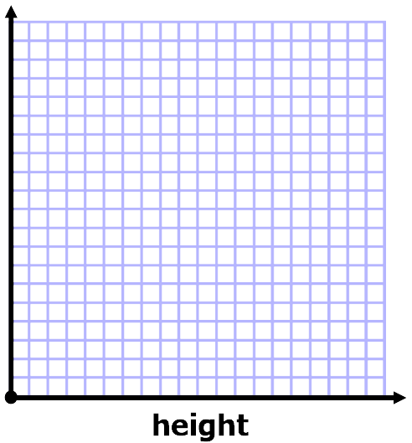
7) What is another variable (other than vocabulary) that would have positive association with a person’s height? Draw a possible scatterplot.
8) What is a variable that you would expect to have no association with a person’s height? Draw a possible scatterplot.

Predict a Survey
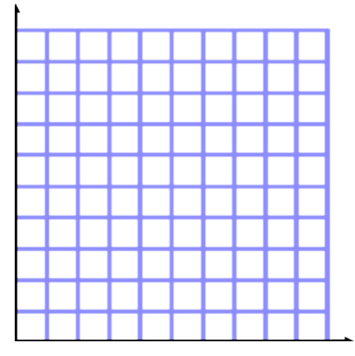
9) Suppose you were to survey 30 students, asking them about their test scores, and the number of hours of screen time they have each day. What type of association would you predict? Explain your prediction.

10) Draw a sample scatterplot that would support your prediction.

Answers
1) Positive Association 2) No Association 3) Negative Association
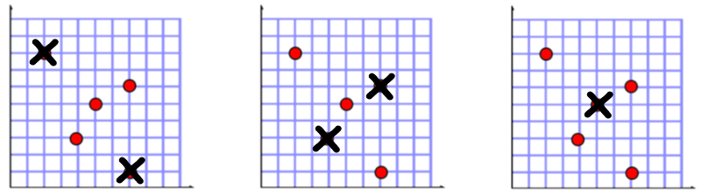
4)
5) Test scores have no association with shoe size. This means that students with small shoes have similar test scores to students with large shoes.
6) A natural gas bill has a negative association with the temperature. This means that the gas bill is higher during months when the temperature is low. It also means the gas bill is low during months when the temperature is high.
7) Example 8) Example
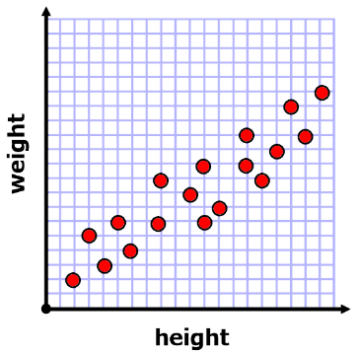
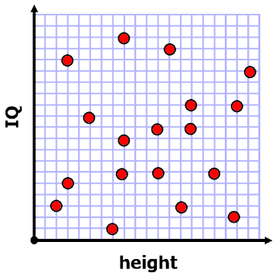

9) Your opinion. Don’t forget to explain. Most students predict that these variables have negative association because students who spend a lot of time watching screens probably don’t have much time left to do homework or to study.
10) If you agree that these variables should have negative association, then your scatterplot should show negative association. The data points should move downward if you look at them from left to right.
Optional Extension: Association in Real-Life Research
Below, you’ll find a summary of a research study. This shows a great example of how researchers use correlation to better understand the great undiscovered questions that humans are curious about.
The big question here: Who is likely to commit a crime?
9) The research summary features higher-level vocabulary than most reading that is usually given to 8th grade students. We left it that way because we thought it might be fun for you to be a scientist for a little while. It’s okay if you don’t fully understand. Do you best to read the passage and then describe what you learned from it.
Background: Violent criminality is at least moderately heritable. Height, a highly heritable trait, may be involved but no study has estimated the effect of height on crime.
Methods: We linked nationwide, longitudinal registers for 760 000 men who underwent mandatory military conscription from 1980 through 1992 in Sweden, to assess the association between height and being convicted of a violent crime.
Results: In unadjusted analyses, height had a moderate negative relationship to violent crime; the shortest of men were twice as likely to be convicted of a violent crime as the tallest. However, when simultaneously controlling for all measured confounders, height was weakly and positively related to violent crime. Intelligence had the individually strongest mitigating effect on the height-crime relationship.
Amber L Beckley Ralf Kuja-Halkola Lena Lundholm Niklas Långström Thomas Frisell
Published in the International Journal of Epidemiology, Volume 43, Issue 3, 1 June 2014

