Name:
Study Guide 1631 ~ Algebra Tiles Intro
Equations with Manipulatives

Try it yourself first
This diagram shows a classic algebra puzzle. The x-tiles represent a mystery number. Can you figure out what the mystery number is?
Some important clues:
- The equal sign in the diagram mean that the left and right side of the puzzle have an equal number.
- Each x-tile is worth the same amount. (You could say that there are three copies of the mystery number.)
1. This lesson will give some good tips on solving this kind of puzzle. But first, take some time to see what you can do with your own intuition (your own ideas). Try to find the mystery number using the puzzle-solving skills you already have.

2. Explain what you tried. If you think you’ve found the correct value, explain how you can be confident that your answer is correct.

One great solution method
3. Students have been solving this type of puzzle for a long time. The next few pictures show the “classic” steps for finding the solution quickly. Most people agree that these are the best steps for solving this kind of puzzle.
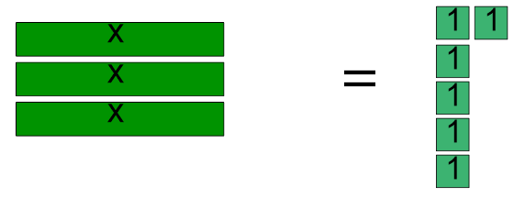
Use algebra tiles to follow the steps in the pictures.
Why three groups?
What is the mystery number?
Divide the tiles into three equal groups.

Subtract four one-tiles from the right to make both sides equal again.
Discuss with your team why this is helpful.
(Also notice that we erased the equal symbol. The two sides of the puzzle are not equal right now.)
Subtract four one-tiles from the left side.

Set up the beginning of the puzzle.
Did you realize that the mystery number is two?
In the final step, when we divided the tiles into three groups, we could see that each x-tiles matched up with two one-tiles.
We can “check” this solution if we look back to the original picture.
If each x-tile is worth two ones, then both sides of the puzzle have ten tiles.
Practice
Try these puzzles with algebra tiles. Discuss with your team the steps that you’re making.
4)
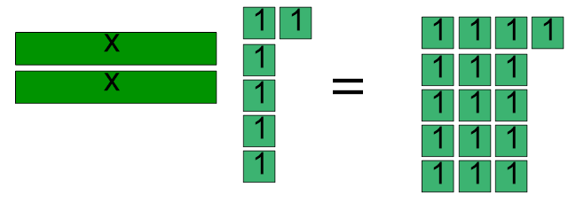

5) (You might need to share algebra tiles with a partner to make sure you have enough.)

You might remember these puzzles from an earlier lesson. Try to represent the puzzles using algebra tiles.

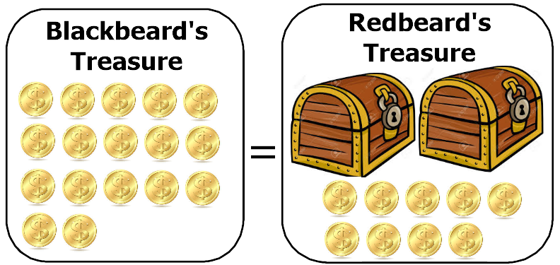
6) How many gold coins are in each treasure chest?

7) How many germs are hiding in each gym sock?
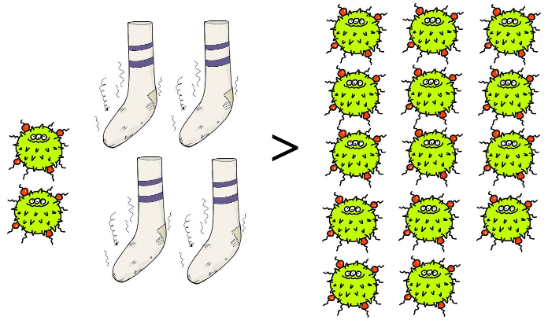

8) Create your own puzzle with algebra tiles. Check to make sure that your puzzle has a solution.
9) Ask a partner to solve your puzzle.

